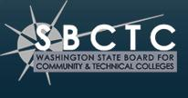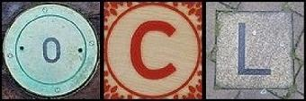
Credit: Timothy Valentine & Leo Reynolds CC-BY-NC-SA

The course materials you are viewing were created as part of the Open Course Library (OCL) project. The OCL is a collection of courses designed by a cooperative of faculty members in Washington State starting in 2011. The courses, and our maintenance of them, are complete as of March 2013.

All of our work is available for use and adoption by anyone at any time. We release materials created by our team using a Creative Commons (CC By) license.

Some materials associated with this course might have be made available through cooperation of the original copyright holder. In these cases please follow the distribution restrictions as defined by the specific material.

To attribute this course please use the names of our faculty designer(s):
Alexandra Gouirand
Anne Kelly-Glasoe

Faculty Designer Name

To cite this course please use the following citation example:
Gouirand, Alexandra & Anne Kelly-Glasoe. Open Course Library: FRCH&123 French III. The Open Course Library. Washington State Board for Community & Technical Colleges, xx March, 2013. Web. Date of access.

